Error: Reference source not found
–
Document ID:
Author(s): TN Team
Version: 0.2
Date: April 4, 2024

1. Objective and Scope 3
2. Project End Users 3
3. Project scope 3
4. Glossary…………………………………………………………………………………………………………….3
5. User Classes and characteristics…………………………………………………………………………..4
6. Programming Language………………………………………………………………………………………4
7. Database Server…………………………………………………………………………………………………4
8. Requirement Specification…………………………………………………………………………………..4
9. Functional Requirements…………………………………………………………………………………….5
10. Non Functional Requirements…………………………………………………………………………….6
11.
3.7 Reports 8

Objective and Scope
The introduction of the Software Requirements Specification (SRS) provides an overview of the entire SRS with purpose, scope, definitions, acronyms, abbreviations, references and overview of the SRS. The aim of this document is to gather and analyses then give an in-depth insight of the complete NSTU Bus Tracking System by defining the problem statement in detail. Nevertheless, it also concentrates on the capabilities required by stakeholders and their needs while defining high-level product features. The detailed requirements of the NSTU Bus Tracking System are provided in this document.
Project End Users
The main purpose of this project is to provide the real time location and direction of the bus. Drivers can easily access and implement servicing schedules for the buses, which ensures are roadworthy at all times thus we will ensure a timely maintainable project.
Project Scope
We want to build a system which will track the current position and direction of the bus and show it to the user who wants to travel by the bus. The driver will share his location that’s will show to the user the current position of bus. The system will reduce the waiting time for travelling
Glossary
This subsection contains definitions of all the terms, acronyms, and abbreviations used in the document. Terms and concepts from the application domain are defined.
• API – Application Programming Interface
• SRS – Software Requirement Specifications
• UI – User Interface
• SDLC – Software Development Life Cycle
• DBMS – Database Management System.

User Classes and characteristics
There are three types of stakeholders in our “NSTU Bus Tracking System”. Such as:
Driver: Driver share their location which used to provide the user the current location of the bus.
Student: Student can get the current direction and location of the bus when they once logged in to the system.
Teacher: Teacher can get the current direction and location of the bus when they once logged in to the system.
Programming Language
We will use Java as programming language to develop our application.

Database Server
We will use Firebase database server to store all of the information of this system. The reason
behind to choose the database server are given below:
• Security
• Reporting and Data Mining
• Replication
• Fault tolerance
• Performance diagnostics

Requirement Specification

Functional Requirements
1.Show bus location in real time
Show information to user in real time. When the user request to system the location of the bus then it will show the current location of the bus. Stakeholders are Student, Teacher, Driver. Priority will be High.
2.Save real time location records of bus when driver start ride
Save real time location records of bus when driver start ride.When driver start ride the real time location records of bus will be stored on database so that later it will be process to ready for students and teachers so that they can see the bus location. Stakeholders are Driver.
3.Verify the user with institutional email
Verify the user with institutional email. When user register to the system, a verification email will send to user institutional email. Stakeholders are Student, Teacher, Driver.
4.Show the currently available bus location in a map
Show the currently available bus location in a map .When the user logged in to the system then system will show currently available buses location in the google map. Stakeholders are Student, Teacher.
5.Save real time location of currently logged in users
Save real time location of currently logged in users .When user logged in to the system then the system will retrieve the user location using their device location. Stakeholders are Student, Teacher.
6.Administrator manage all the user
Administrator will manage all the registered user and bus schedule as required. Stakeholders are Administrator.
7.Emergency contact with administrator
Emergency contact with administrator Description User can contact with administrator in any emergency situation. Stakeholders are Driver.
Non Functional Requirements
1.Performance Requirements
It is very important to maintain performance of any software system. To ensure performance, we need to maintain some steps. Now, I will explain some perspective by which we are going to enhance the performance of our project.
2.Speed & Latency Requirements
Speed and latency requirements must be ensured while retrieving data from the bus positioning module.
3.Capacity Requirements
The developed system by us must be capable to handle user data, provide accurate information, handling database, manage http request etc.

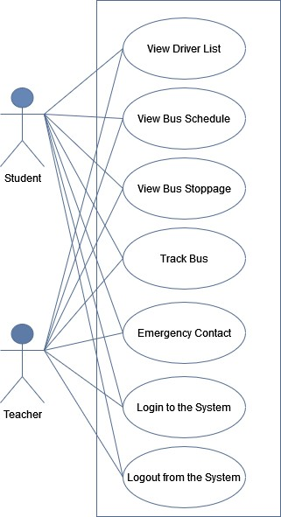
Fig-1: Teacher and Student activities
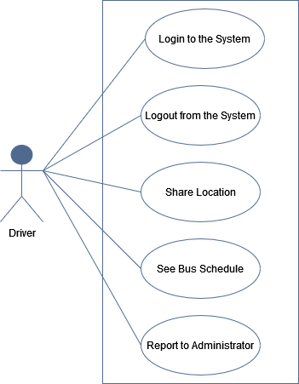
Fig-2: Driver activities
4.Security Requirements
• Signing in with an educational email in a student/teacher module
• Get access according to logged in user
• Signing out as a student/teacher
• Handling encrypted passwords
5.Ease of Use Requirement
Application must be usable for the end users. This app is enough usable to the teacher, student and bus driver by which they can operate this system easily. Stakeholders are Student, Teacher, Bus Driver.
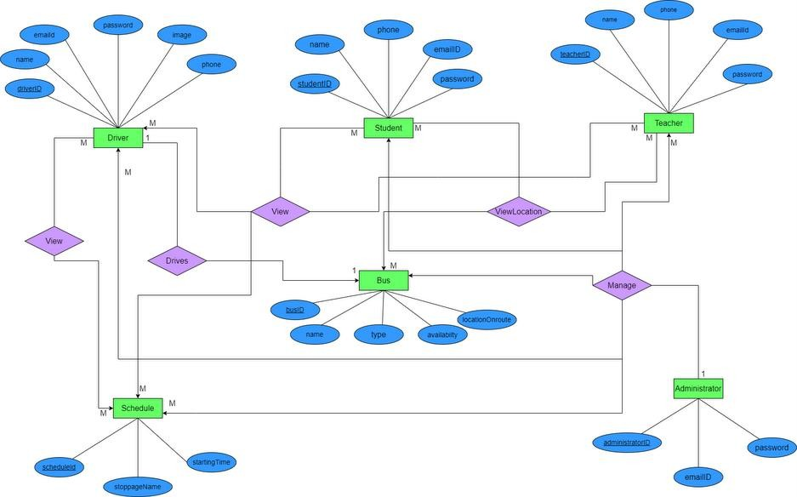

ER DIAGRAM

